Hive Hands-On Exercise — Sales Data Analysis

1. Objective
The objective of this exercise is to perform basic and intermediate data-processing operations using Apache Hive on top of the Hadoop ecosystem.
The exercise demonstrates:
- Creating and using a Hive database.
- Creating and loading data into a managed Hive table.
- Performing filtering, sorting, and aggregation operations.
- Performing JOIN operations between two Hive tables.
- Creating and querying an external partitioned table.
- Understanding partition pruning.
- Using EXPLAIN to view the Hive query execution plan.
- Exploring table metadata using DESCRIBE and DESCRIBE FORMATTED.
- Understanding Hive optimization concepts such as MapJoin and indexing.
The implementation was performed using Hadoop 3.4.2 and Hive 3.1.3 in a Linux/WSL environment.

2. Procedure

Part A — Basic Table Operations

Step 1: Connect to Hive
The Hive shell was started from the terminal using:
hive

The Hive session started successfully after resolving the Hadoop NameNode Safe Mode issue.

Step 2: Create Database
A database named sales_db was created and selected:
CREATE DATABASE IF NOT EXISTS sales_db;
USE sales_db;

Step 3: Create Managed Table
A managed table named sales_data was created with the following fields:
- Transaction ID
- Customer ID
- Product Name
- Category
- Price
- Quantity
- Sale Date
- Region
The table uses comma-separated values and the TEXTFILE storage format.

Step 4: Create Sample Data
A CSV file named sales_data.csv was created in the user's home directory containing 10 sales transactions.

Step 5: Load Data
The CSV data was loaded into the Hive table using:
LOAD DATA LOCAL INPATH '/home/mahi/sales_data.csv'
OVERWRITE INTO TABLE sales_data;

Step 6: Verify Data
The loaded records were verified using:
SELECT * FROM sales_data LIMIT 10;

Part B — Querying Data
Several Hive queries were performed on the sales_data table.

Filtering
Electronics products were retrieved using:
SELECT *
FROM sales_data
WHERE category = 'Electronics';

Sorting
The sales records were sorted by sale date in descending order:
SELECT *
FROM sales_data
ORDER BY sale_date DESC;

Aggregation
Total revenue was calculated for each category:
SELECT category,
SUM(price * quantity) AS total_revenue
FROM sales_data
GROUP BY category
ORDER BY total_revenue DESC;

Average price and transaction count were calculated using:
SELECT category,
AVG(price) AS avg_price,
COUNT(*) AS count
FROM sales_data
GROUP BY category;

Total quantity sold for each product was calculated using:
SELECT product_name,
SUM(quantity) AS total_sold
FROM sales_data
GROUP BY product_name
ORDER BY total_sold DESC;

HAVING Clause
Categories with revenue greater than 1000 were identified using:
SELECT category,
SUM(price * quantity) AS revenue
FROM sales_data
GROUP BY category
HAVING SUM(price * quantity) > 1000;

JOIN Operation
A second table named customers was created containing customer ID, name, city, and joining date.
The two tables were joined using customer_id:
SELECT s.transaction_id,
c.name,
c.city,
s.product_name,
s.price
FROM sales_data s
JOIN customers c
ON s.customer_id = c.customer_id
LIMIT 10;

During execution, Hive attempted to use a MapJoin and encountered a missing Apache Commons Collections dependency. The query itself was valid; the issue occurred during MapReduce execution. The automatic MapJoin optimization was disabled using:
SET hive.auto.convert.join=false;

Part C — External Tables and Partitioning
An external table named sales_external was created.
Unlike the managed table, sales_external uses an HDFS location and has sale_date as its partition column.
Two partitions were created:
sale_date=2024-01-15
sale_date=2024-01-16

Data was inserted into the first partition using:
INSERT OVERWRITE TABLE sales_external
PARTITION(sale_date='2024-01-15')
SELECT transaction_id,
customer_id,
product_name,
category,
price,
quantity,
region
FROM sales_data
WHERE sale_date = '2024-01-15';

The second partition was created using:
INSERT OVERWRITE TABLE sales_external
PARTITION(sale_date='2024-01-16')
SELECT transaction_id,
customer_id,
product_name,
category,
price,
quantity,
region
FROM sales_data
WHERE sale_date = '2024-01-16';

The partitions were verified using:
SHOW PARTITIONS sales_external;

A partition-specific query was then executed:
SELECT *
FROM sales_external
WHERE sale_date = '2024-01-15';

This demonstrates partition pruning, where Hive can restrict the data scan to the required partition.

Part D — EXPLAIN and Optimization

EXPLAIN
The execution plan for an aggregation query was generated using:
EXPLAIN
SELECT category,
SUM(price * quantity)
FROM sales_data
GROUP BY category;

The EXPLAIN command displays the stages and operators Hive uses to execute the query.

Index
The exercise also included creation of an index on the category column:
CREATE INDEX sales_idx
ON TABLE sales_data (category)
AS 'COMPACT'
WITH DEFERRED REBUILD;

Table Metadata
Detailed table information was viewed using:
DESCRIBE FORMATTED sales_data;

The basic table schema was viewed using:
DESCRIBE sales_data;

3. Source Code

Database Creation
CREATE DATABASE IF NOT EXISTS sales_db;
USE sales_db;

Managed Table
CREATE TABLE sales_data (
transaction_id INT,
customer_id INT,
product_name STRING,
category STRING,
price DOUBLE,
quantity INT,
sale_date STRING,
region STRING
)
ROW FORMAT DELIMITED
FIELDS TERMINATED BY ','
STORED AS TEXTFILE;

Load Sales Data
LOAD DATA LOCAL INPATH '/home/mahi/sales_data.csv'
OVERWRITE INTO TABLE sales_data;

Basic Queries
SELECT *
FROM sales_data
WHERE category = 'Electronics';

SELECT *
FROM sales_data
ORDER BY sale_date DESC;

Aggregation Queries
SELECT category,
SUM(price * quantity) AS total_revenue
FROM sales_data
GROUP BY category
ORDER BY total_revenue DESC;

SELECT category,
AVG(price) AS avg_price,
COUNT(*) AS count
FROM sales_data
GROUP BY category;

SELECT product_name,
SUM(quantity) AS total_sold
FROM sales_data
GROUP BY product_name
ORDER BY total_sold DESC;

HAVING Query
SELECT category,
SUM(price * quantity) AS revenue
FROM sales_data
GROUP BY category
HAVING SUM(price * quantity) > 1000;

Customer Table
CREATE TABLE customers (
customer_id INT,
name STRING,
city STRING,
join_date STRING
)
ROW FORMAT DELIMITED
FIELDS TERMINATED BY ','
STORED AS TEXTFILE;

Load Customer Data
LOAD DATA LOCAL INPATH '/home/mahi/customers.csv'
OVERWRITE INTO TABLE customers;

JOIN
SELECT s.transaction_id,
c.name,
c.city,
s.product_name,
s.price
FROM sales_data s
JOIN customers c
ON s.customer_id = c.customer_id
LIMIT 10;

If required for the MapJoin dependency issue:
SET hive.auto.convert.join=false;

External Partitioned Table
CREATE EXTERNAL TABLE IF NOT EXISTS sales_external (
transaction_id INT,
customer_id INT,
product_name STRING,
category STRING,
price DOUBLE,
quantity INT,
region STRING
)
PARTITIONED BY (sale_date STRING)
ROW FORMAT DELIMITED
FIELDS TERMINATED BY ','
STORED AS TEXTFILE
LOCATION '/user/hive/warehouse/sales_ext';

Partition Creation
INSERT OVERWRITE TABLE sales_external
PARTITION(sale_date='2024-01-15')
SELECT transaction_id,
customer_id,
product_name,
category,
price,
quantity,
region
FROM sales_data
WHERE sale_date = '2024-01-15';

INSERT OVERWRITE TABLE sales_external
PARTITION(sale_date='2024-01-16')
SELECT transaction_id,
customer_id,
product_name,
category,
price,
quantity,
region
FROM sales_data
WHERE sale_date = '2024-01-16';

Partition Queries
SHOW PARTITIONS sales_external;

SELECT *
FROM sales_external
WHERE sale_date = '2024-01-15';

EXPLAIN
EXPLAIN
SELECT category,
SUM(price * quantity)
FROM sales_data
GROUP BY category;

Index
CREATE INDEX sales_idx
ON TABLE sales_data (category)
AS 'COMPACT'
WITH DEFERRED REBUILD;

Table Description
DESCRIBE sales_data;

DESCRIBE FORMATTED sales_data;

4. Screenshots
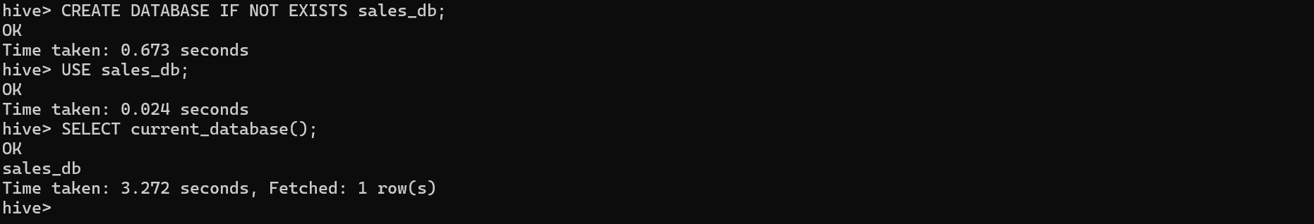
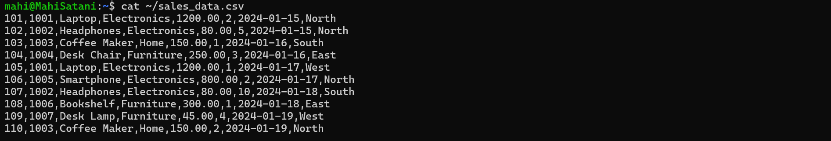
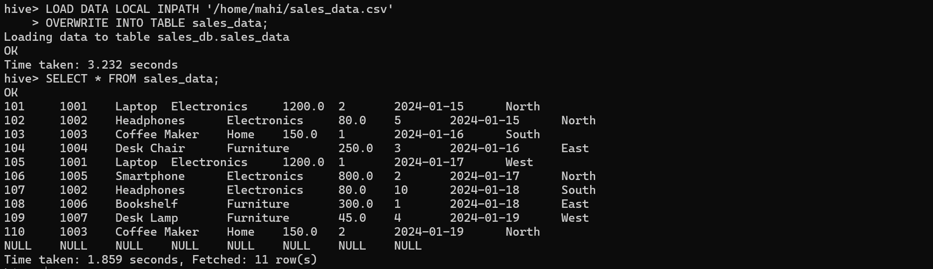
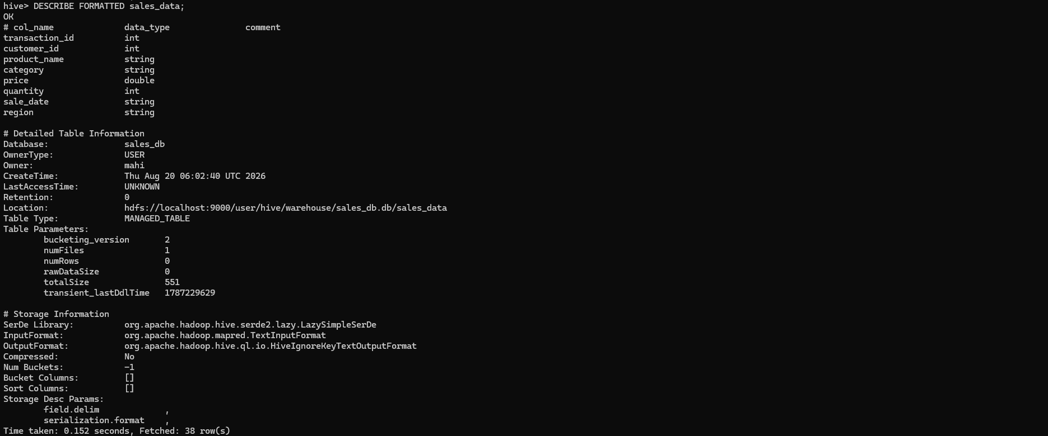
1. Basic Queries
Step 1: Display all Electronics records
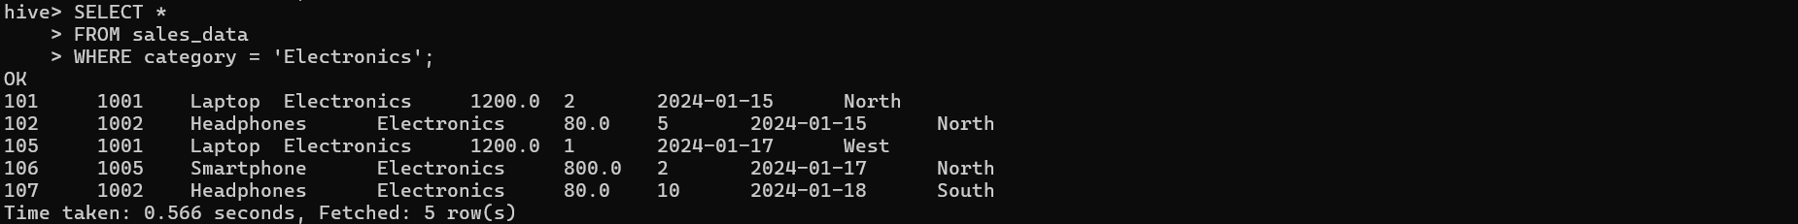
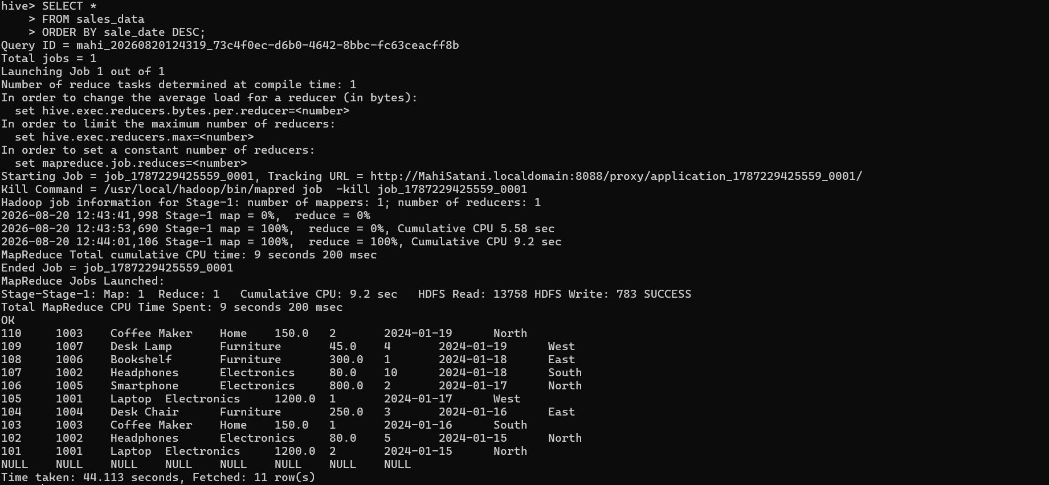
2. Aggregation Queries
Step 1: Total Revenue by Category
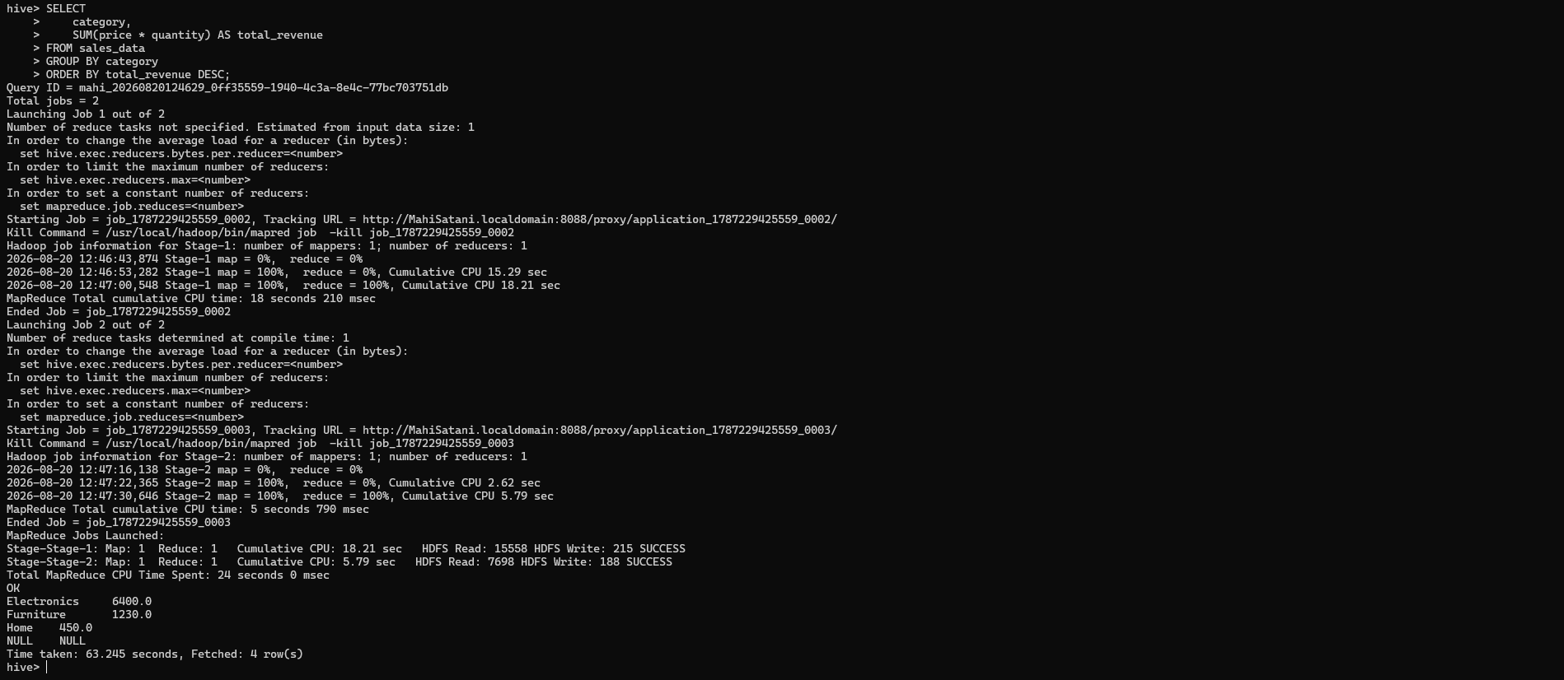
Step 2: Average Price Per Category
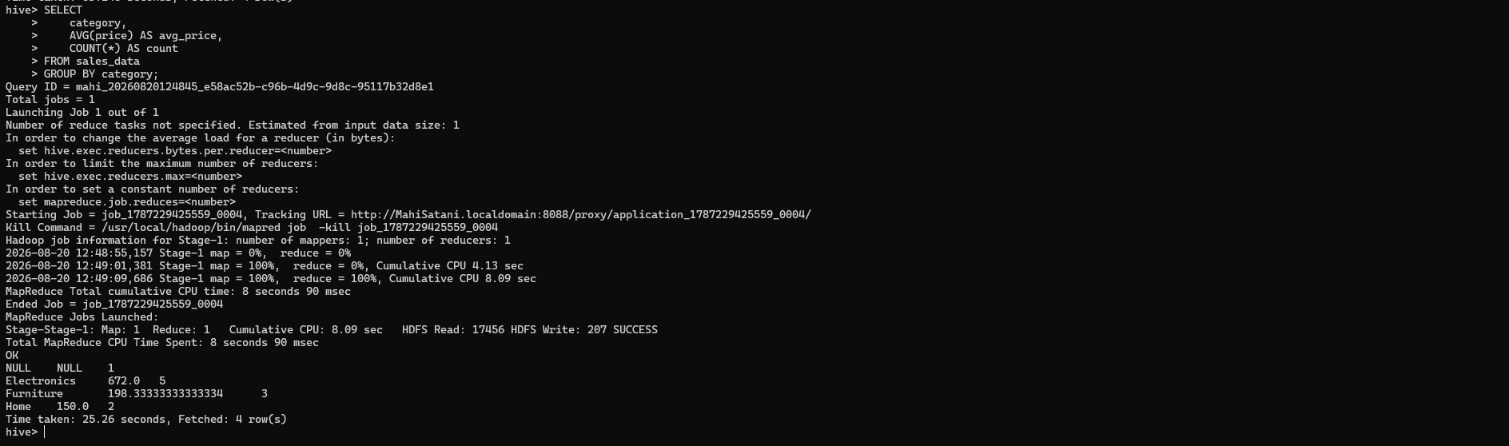
Step 3. Total Quantity Sold Per Product
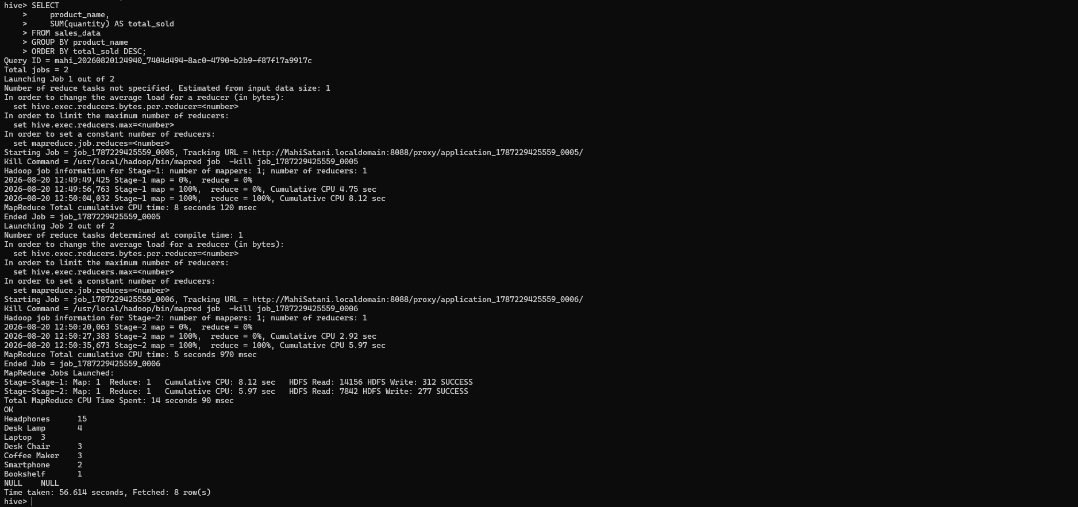
3. HAVING Clause
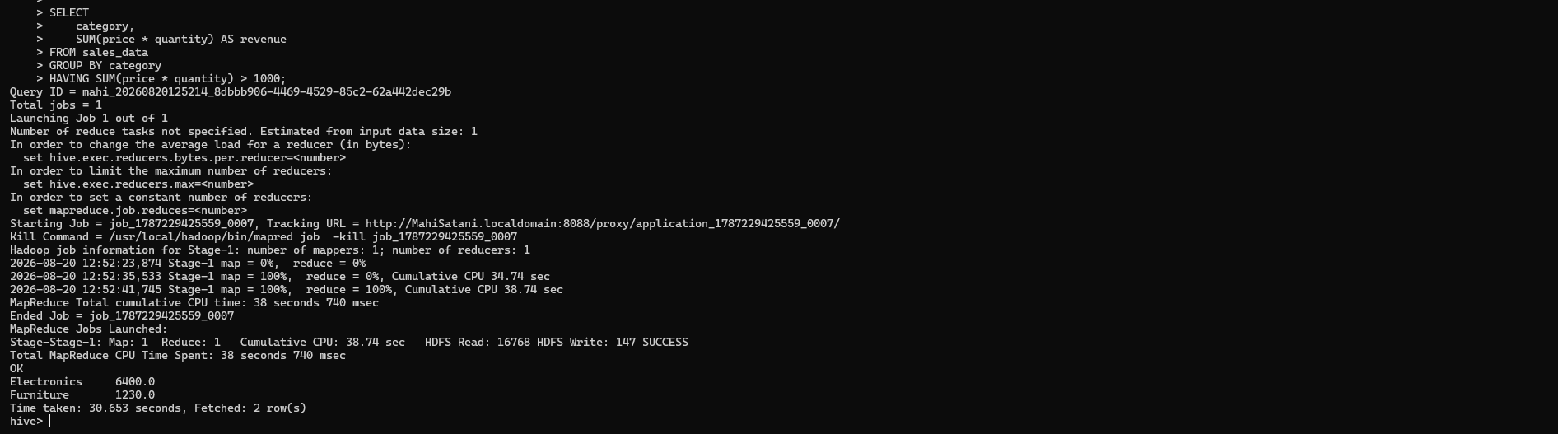
4. Join Operations
Step 1: Create Customers Table
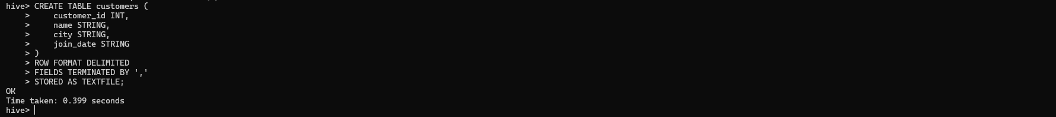
Step 2: Create Customer CSV
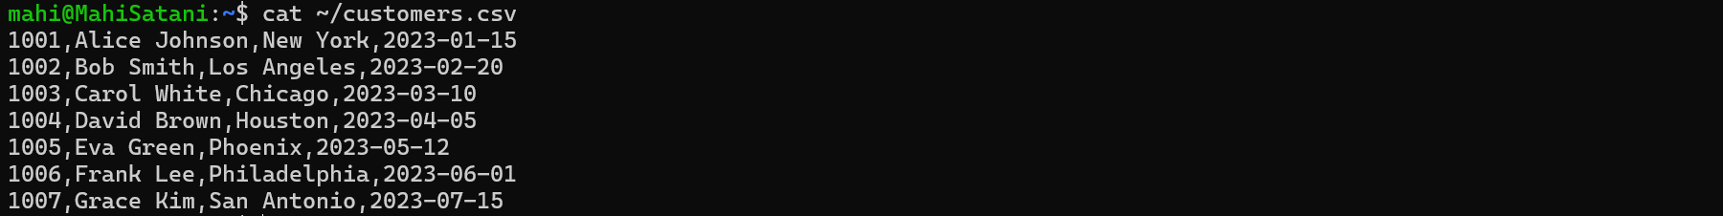
Step 3: Load Customer Data
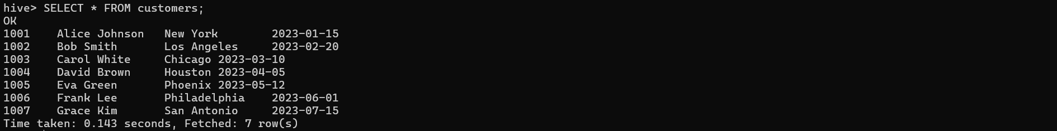
Step 4: Perform the JOIN
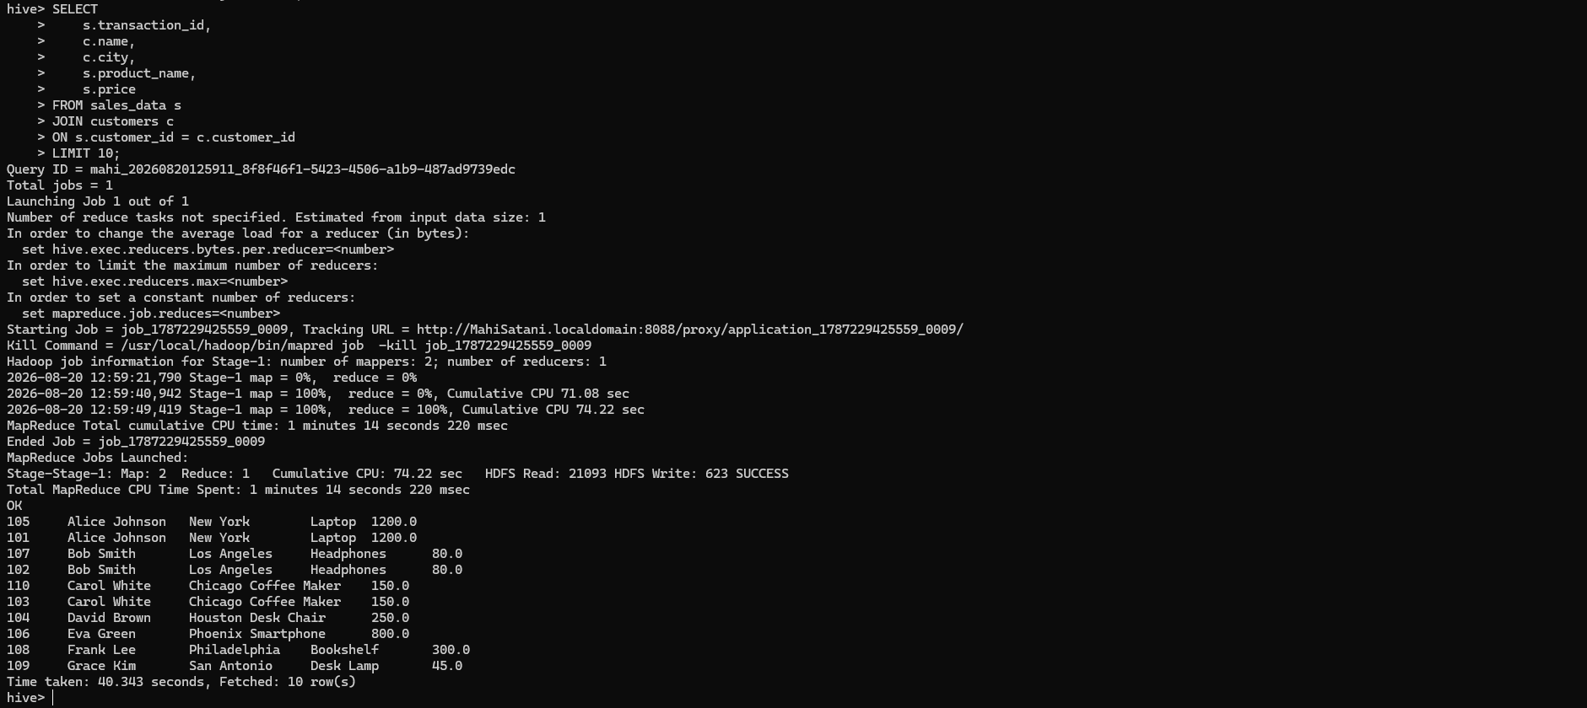
5. External Tables and Partitioning
Step 1: Create the External Table
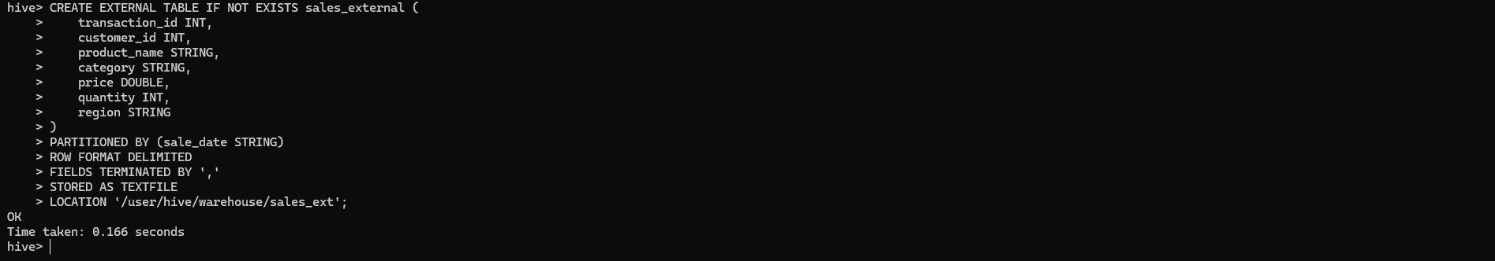
Step 2: Verify the Tables
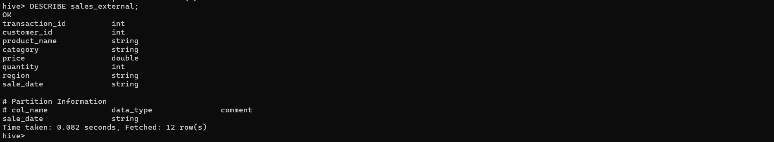

Step 3: Create the First Partition
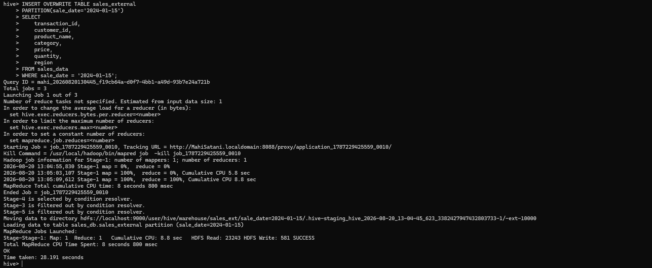
Step 4: Create the Second Partition
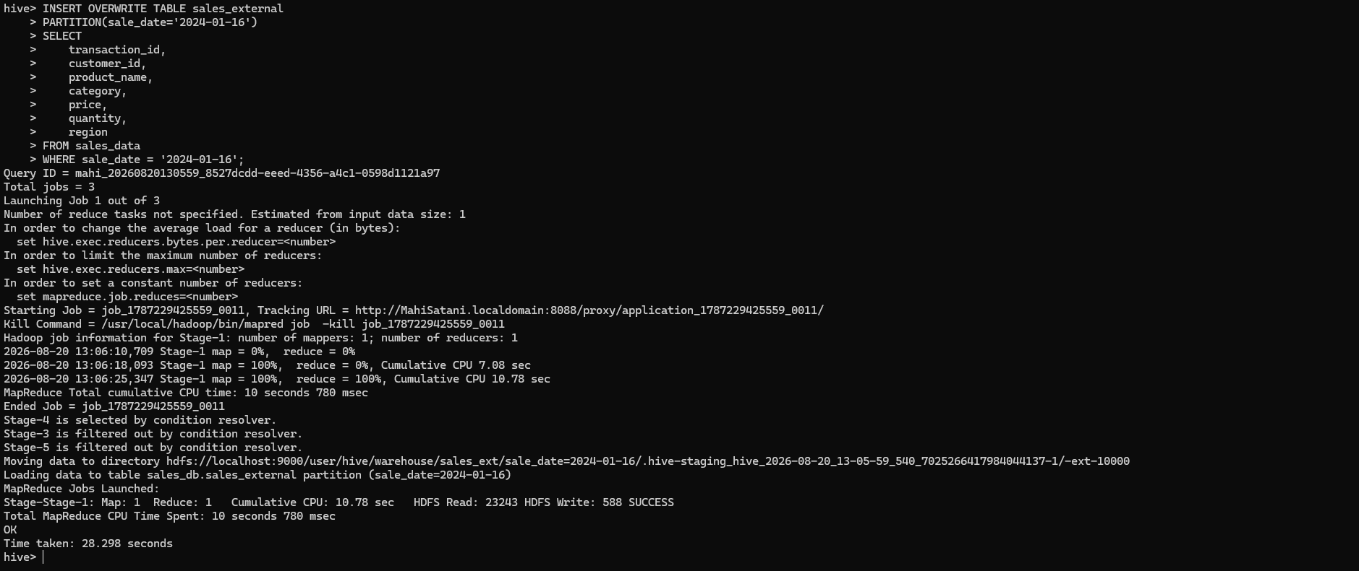
Step 5: Show the Partitions
Step 6: Query a Specific Partition
Step 7: Understand Partition Pruning
Step 8: Check the HDFS Partition Directories
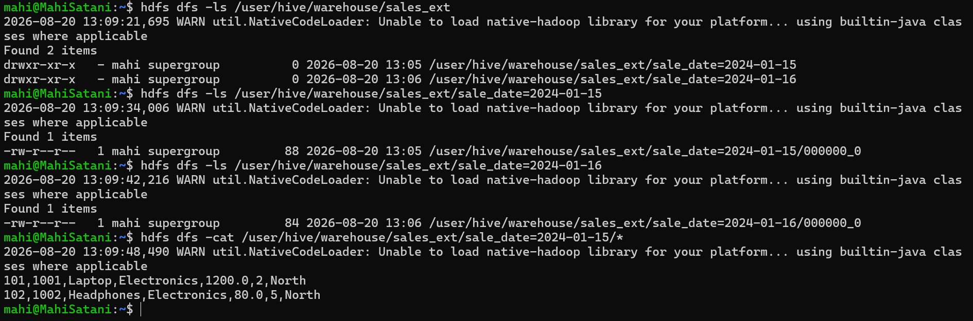
6. EXPLAIN and Optimization
Step 1: EXPLAIN Query Plan

Step 2: View Table Details
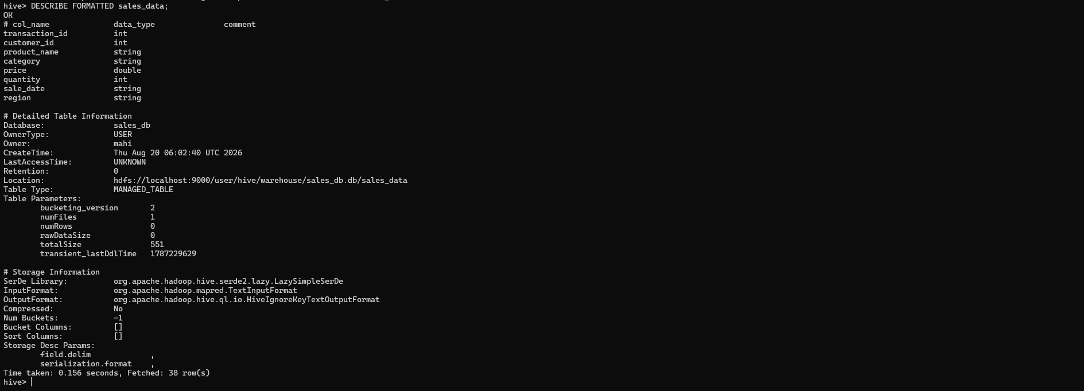

5. Conclusion
The Hive hands-on exercise successfully demonstrated the use of Apache Hive for data storage, querying, aggregation, joining, partitioning, and query optimization.
A managed table named sales_data was created and populated with sales transaction data. Various Hive operations such as SELECT, WHERE, ORDER BY, GROUP BY, SUM, AVG, COUNT, and HAVING were performed to analyze the sales data.
A separate customers table was created to demonstrate relational JOIN operations. An external partitioned table was also created, with sales data organized by sale_date. Partition filtering demonstrated how partitioning can reduce unnecessary data scanning.
Finally, the EXPLAIN command was used to understand Hive's query execution plan, while DESCRIBE and DESCRIBE FORMATTED were used to inspect table structure and metadata.
Overall, the exercise provided practical understanding of how Hive works with Hadoop to perform distributed data processing and SQL-like analytics on large datasets.





1. Basic Queries
Step 1: Display all Electronics records


2. Aggregation Queries
Step 1: Total Revenue by Category

Step 2: Average Price Per Category

Step 3. Total Quantity Sold Per Product

3. HAVING Clause

4. Join Operations
Step 1: Create Customers Table

Step 2: Create Customer CSV

Step 3: Load Customer Data

Step 4: Perform the JOIN

5. External Tables and Partitioning
Step 1: Create the External Table

Step 2: Verify the Tables


Step 3: Create the First Partition

Step 4: Create the Second Partition

Step 5: Show the Partitions
Step 6: Query a Specific Partition
Step 7: Understand Partition Pruning
Step 8: Check the HDFS Partition Directories

6. EXPLAIN and Optimization
Step 1: EXPLAIN Query Plan

Step 2: View Table Details


